**English Game: Simon Says**

This game helps with understanding classroom English and allows students to have fun whilst learning. This is a game often played by Western children in Elementary schools.

The teacher should give out instructions, such as classroom English instructions, and to have the students perform those instructions.

There is a catch though; the students should only follow the instructions if they begin with ‘Simon says.’ If they follow an instruction that has not begun with ‘Simon says’ then they have followed an incorrect instruction.

Teachers giving instructions should give a mixture of correct instructions, starting with ‘Simon says,’ and incorrect instructions, which do not begin with ‘Simon says.’

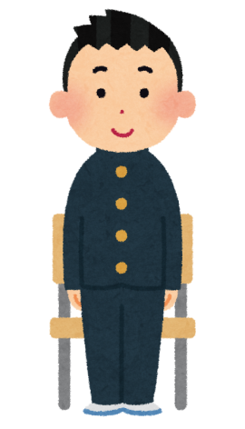Example:

Simon says, please stand up

This is correct! The student stood up because the teacher started the instruction with ‘Simon says.’



Raise your hand

This is incorrect, the student has raised her hand but the teacher did not say ‘Simon says.’

This game encourages listening and comprehension. They have to listen for the correct instruction and then perform it, showing that they understand the instruction. This will help them to understand classroom English so that when the teacher uses these instructions in class the students will know how to respond.

However, not all classroom English is suitable for this game as it has to be an instruction that all the students can do together.

**Classroom English that can be used in a ‘Simon Says’ game**

1. Good Morning (students should respond with Good Morning)
2. Good Afternoon (students should respond with Good Afternoon)
3. Please stand up
4. Please sit down
5. Please come to the front
6. Please go to your desk
7. Please raise your hand
8. Make a pair
9. Make a group of 4

Feel free to add more classroom English if you think it is suitable!

**Competitive**

If you wish to motivate your students through a little friendly competition you can have a point system.

For every correct instruction they follow they give themselves a point. If they fail to do the right action or follow an incorrect instruction (there is no ‘Simon says’) then they do not get a point. The student/s with the highest score wins.

(It’s a good idea to know how many correct instructions you give so you know what the maximum amount of points will be.)