Clock Practice

http://3.bp.blogspot.com/-oH9e-jdid9E/UbVvL2XmOEI/AAAAAAAAUrE/D86b6TD19XM/s800/clock_short_hand.png http://1.bp.blogspot.com/-B_jWj-O_o8M/UbVvLjyHSYI/AAAAAAAAUq8/96hI8VAtQHA/s800/clock_long_hand.png

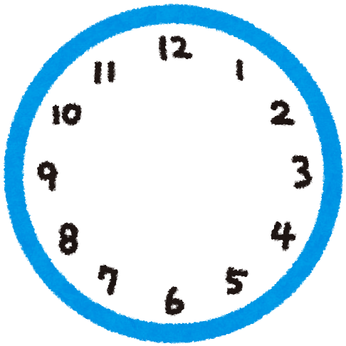

<http://www.irasutoya.com/>