Spelling the seasons!

Practicing English spelling and handwriting

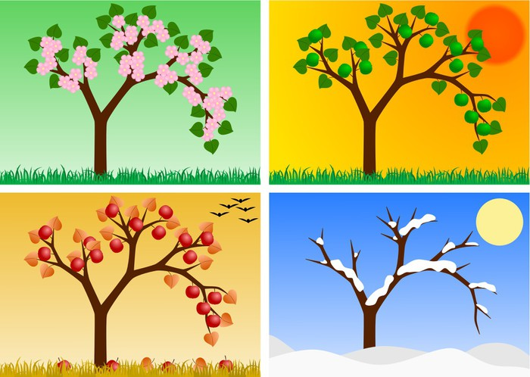

This season is spring

This season is



This season is summer

This season is



This season is autumn

This season is



This season is winter

This season is