The Seasons: Missing words

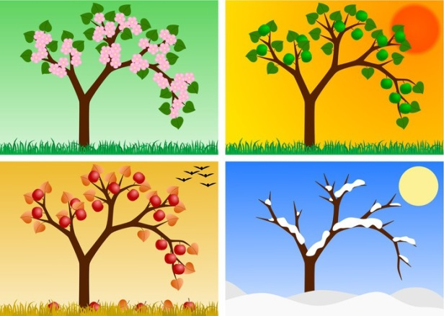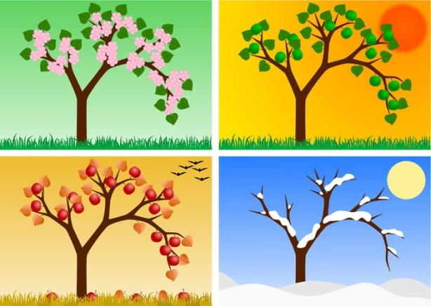

Fill in the blank spaces. Use the words at the bottom.

There are 4 __________________.

They are winter, spring, summer, and _______________.

In winter it can be very cold and it can ______________.

In spring many people see the ________________________.

In ________________ it is very hot and many people go to the beach. In autumn the leaves turn __________ and fall.

autumn

snow

red

seasons

cherry blossom

summer