**Let’s Cook in English! Lesson Plan**

Objective: To familiarize students with vocabulary and phrases related to food and cooking.

|  |  |  |
| --- | --- | --- |
| Est. Time 45min. | Contents | Notes |
| 2-3 min. | **Beginning of Class**  Greeting (挨拶)  “Hello, How are you today?”  Weather, Date, Time, etc.  天気、日付、時間、  Review  What did we do last time? | Try to ask many students questions.  (Also try to avoid the answer “I’m fine, thank you,” and instead offer different answers such as “I’m sleepy, I’m hungry, etc.”)  If you have time, review a little bit of the English taught in the previous class. |
| Total:  25-35 min.  1-3 min.  3-5 min.  5-10 min.  10-15 min. | **Let’s Cook in English!** (PowerPoint)  **Warm up!**  “What food do you like?” “What dish can you make/cook?”  **Vocabulary:**  Ingredients, Food vocabulary (Flashcards)  Let’s Make Curry  “What are the ingredients of curry?”  **Let’s Cook! / Ingredient List Worksheet** (Pair work/Individual)  “What do you want to cook?” | Introduce the topic.  “Talk with a partner about which food you like or can cook.”  For a few minutes, students should talk with a partner or group.  Repeat each vocabulary word (x2). Go back and repeat vocabulary words when they appear again in the lesson.  It’s okay if students answer in Japanese first, but repeat the words in English to help them remember the new vocabulary. (Repeat vocab as much as possible).  In pairs, have students think about a dish and what ingredients it needs.  Fill in the worksheet.  Let’s Cook / Ingredient List Worksheet  Students can work in pairs and draw how to cook a dish.  The Ingredient List Worksheet can be used if you have a lot of class time left. (The Ingredient List Worksheet should be used before the Let’s Cook Worksheet)  Have ALT help with simple English directions. |
| 1-3 mins. | **End of Class** Have students reflect and give their thoughts at the end of the lesson. “That’s all for today! See you!” | As a group, have students give their opinion of the class. Say good bye. |

**Detailed Lesson Plan**

**Beginning of Class:**Begin the class with the appropriate greetings. Be enthusiastic and try to add energy to the class!   
Include what students have learned in past lessons: Date, Day of the week, Weather, etc.   
When asking “How are you?” try to encourage students to try different answers than “I’m fine.” For example, “I’m hungry,” “I’m sleepy,” “I’m okay,” etc.   
  
Try to use classroom English throughout the lesson so students can listen and review it without having it as the main topic of the lesson.

**Let’s Cook in English PowerPoint:**Warmup:Have students talk about what food they like and what food they can cook. During this time, you can use flashcards (not included) to review food vocabulary in English. Use this time to see what words your students know in English. By using flashcards, you can also quiz your students to see how well they remember the vocabulary.   
Use the PowerPoint to introduce new words and phrases. When students answer questions in Japanese, teach them the English words and have them repeat after you.

Use the phrases given in the PowerPoint notes if you need help on what English phrases to use when talking to your students.

**Let’s Cook/ Ingredient List Worksheet:**   
This activity can be done in pairs or on their own. Give each student a worksheet.   
First, have students decide what food they want to make.   
Second, have students think about what ingredients they need and write them down in the worksheet. Have them estimate how much they need and how much it will cost.   
Then, tell your students to draw the cooking steps for their dish. For each step, students should write a sentence or phrase in Japanese.   
Next, students can ask the teacher how to say cooking phrases in English if they do not know. This can be done as a class, so if there are any students with the same step, they can write down the English. The teacher should repeat the phrase so everyone can practice.

Note: You can choose to not use the Ingredient List Worksheet if there is not enough time left in class.

**End of Class:**If there is time at the end of class, have some students (individually or in pairs) present what food they want to cook.   
If your next English class is soon, you can hint or briefly introduce the new topic before ending the class.

Practice usually greetings for the end of class.

**Notes:**Throughout the lesson, try to involve as many students as possible, especially when asking questions. If students have trouble understanding, have them work in pairs or groups. Repeat vocabulary when it comes up again throughout the lesson. Use gestures when possible, and try to limit the amount of Japanese used by teachers. Don’t be afraid to use English!

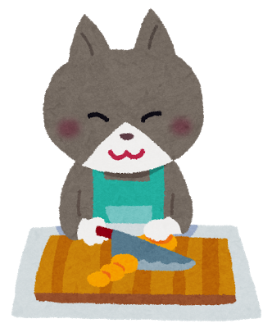Let’s cook!

How to cook ______________

|  |  |
| --- | --- |
| Step 1  _________________ | Step 2  _________________ |
| Step 3  _________________ | Step 4  _________________ |
| Step 5  _________________ | Finished! |

Step 1:  
Step 2:  
Step 3:   
Step 4:  
Step 5:

Ingredient List

What ingredients do you need?

|  |  |  |  |
| --- | --- | --- | --- |
|  | Ingredients | How many? /How much? # | Cost ***¥*** (How much?) |
| 1. |  |  |  |
| 2. |  |  |  |
| 3. |  |  |  |
| 4. |  |  |  |
| 5. |  |  |  |
| 6. |  |  |  |
| 7. |  |  |  |
| 8. |  |  |  |
| 9. |  |  |  |
| 10. |  |  |  |
|  |  |  | Total: |

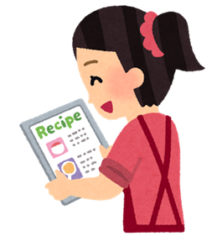

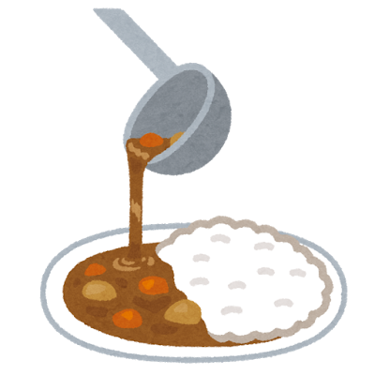

I want to cook ________________.

**Cooking in English**

|  |  |
| --- | --- |
| 料理をする | Cooking |
| 材料 | Ingredients |
| 茹でる | To boil |
| 焼く* | To bake; To grill |
| 炒める | To fry; to stir-fry; to sauté |
| 揚げる* | To fry; to deep fry |
| 蒸す | To steam |
| 皮をむく | To peel |
| 泡立てる | To whisk |
| 混ぜる | To mix; to stir |
| に浸す* | To soak; to marinate |
| マリネする | To marinate (Noun 🡪marinade; ex. Put in a marinade) |
| 煮る* | To simmer; To boil; to stew |
| 切る | Cut; slice |
| 千切りにする* | To julienne; to shred; to cut into fine strips |
| おろす* | To grate; to grind |

*Depends on the situation

**Cooking in English**

|  |  |
| --- | --- |
| Commonly Used Ingredients in Japan | |
| 醤油 | Soy sauce |
| お酒* | Sake; Japanese alcohol |
| みりん* | Sweet rice wine |
| 酢 | Vinegar; |
| 白滝* | Shirataki; Konnyaku noodles; Noodles made from konnyaku​ |
| こんにゃく* | Konnyaku; Jelly made from konjac potatoes |
| 味噌* | Miso |
| かつお節 | Bonito flakes |
| ごま | Sesame seeds |
| だし | Fish and seaweed soup stock |
| 昆布* | Kombu; kelp |
| 大根* | Daikon; Daikon radish |
| ねぎ | Leek |
| 油揚げ | Fried Tofu |
| きな粉* | Roasted soybean flour |
| のり | Seaweed |
| わかめ* | Wakame (a kind of seaweed) |
| パン粉 | Panko breadcrumbs; breadcrumbs |
| 小麦粉 | Flour |

*In the case of some Japanese food, there is no easy translation, so it is okay to use the Japanese word.

**Notes:**Consult an ALT if you really want to know how to explain some Japanese ingredients or dishes.   
Bring a dictionary to class for you and your students to use!