Lilly Pulitzer – the Lady Who Created Colorful Clothes (Basic 21)

Lilly Pulitzer, a fashion designer who started creating colorful clothes in the 1950s, died at the age of 81. Ms. Pulitzer grew up in a rich family and also married into a rich family in 1952. She had three children within five years with her first husband.
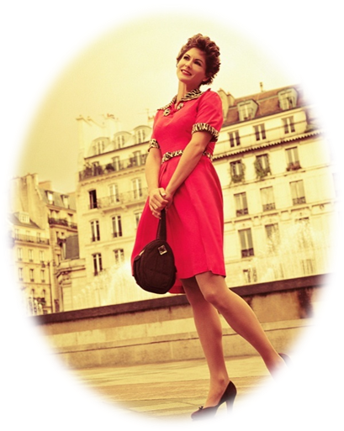
After around five years of being married, Ms. Pulitzer was stressed from her marriage. To help her stop stressing, she started selling fruit, and opened a juice stand with a friend who also came from New York. Both women wanted to hide juice stains on their clothes, so they started wearing colorful patterned dresses.

Her designs became famous. Even Jacqueline Kennedy wore a dressed designed by Lilly. Lilly’s designs are still sold in many department stores, like Bloomingdales, around the world.

Adapted From:
Wilson, Eric. “Heiress Who Gave Elite Clothes a Tropical Splash.” The New York Times. 7 April, 2013. http://www.nytimes.com/2013/04/08/fashion/lilly-pulitzer-socialite-turned-designer-dies-at-81.html?pagewanted=all

