An Indian Tribe Where Women are the Leaders (Basic 19)

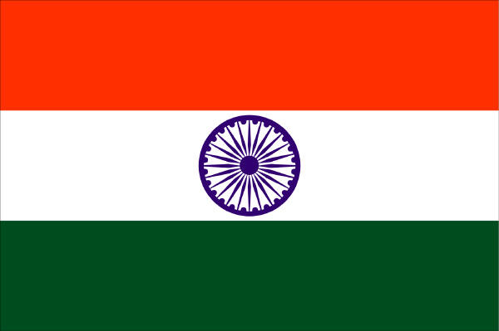
The Khasi tribe is a group of people in the northeastern part of India. In this tribe, women are the leaders – not men. Women are the leaders of society – inside and outside the home. Because of custom, the youngest daughter receives all the family goods. After getting married, the husband moves into the wife’s home. Also the husband and children take the wives’ family name.
This society has existed for thousands of years but some new people, especially men, want to change it. Because only 4 out of 60 women in India are members of parliament, many women think the tribe isn’t bad.

The balance of power is not likely to change anytime soon.

Adapted from:
AFP-JIJI. “Men cry discrimination in Indian tribe where women run the show.” The
Japan Times. March 23rd, 2013. Print.

