Obama is Giving Up 5 Percent of His Pay (Basic 18)
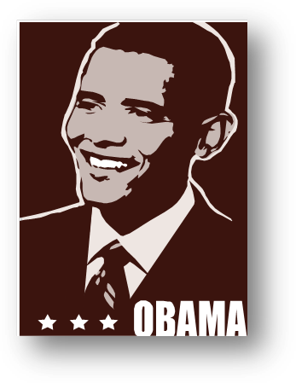
To show understanding with public workers who are underpaid, Obama is giving up 5 percent of his pay ($20,000) this year. According to CNN, Obama’s yearly pay of $400,000 cannot be changed because it is set in law. However starting in April 2013, he will write a check to the U.S. treasury (government) every month.


The president wants to share the financial loss that public workers are now experiencing. From March of this year, public workers will have a pay cut. A White House official said, Obama will cut a part of his pay and pay it back to the Treasury.

A day before Obama’s announcement, the new Defense Secretary Check Hagel said he was cutting his pay.
The pay cuts this year do not include members of Congress.

Adapted from:
Peralta, Eyder. “In Solidarity With Furloughed Workers, Obama Will Give Up 5 Percent Of His Salary.” National Public Radio (NPR). April 3rd, 2013. http://www.npr.org/blogs/thetwo-way/2013/04/03/176182118/in-solidarity-with-furloughed-workers-obama-will-give-up-5-percent-of-his-salary

