Earliest Pot Was Used To Make Fish Soup (Advanced 27)
“Baked fish is good, but wouldn’t it also be good to cook fish soup?” Hunter-gathers, who made the world’s first cooking pots, might have thought this. There is a new study of pottery (pots) made 15,000 years ago in Japan. It shows that the earliest fish soup was made from salmon.

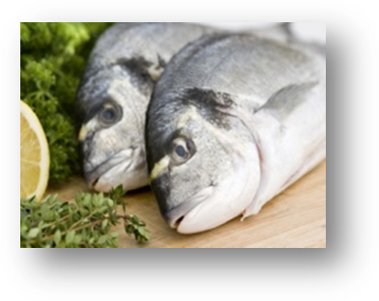
Many scientists thought hunter-gathers were too busy hunting and looking for plants to make pots. However, more recent studies in China and Japan show that people made pots as early as 20,000 years ago – many years before farming.

What were they cooking in the pots? At first, scientists thought they were cooking nuts and plants. But in a new study says it was fish soup. After studying many pieces from old pots, they found out that the pots cooked food from fresh or sea water. Also, the pieces of the pots also had fatty acids from the sea. One scientist said, “We think this may be from salmon.”

According to Peter Jordan, cooking food in a pot is healthier than grilling because all the healthy parts, like oil and fat, stay in the pot when cooking. When grilling, lots of healthy parts fall into the fire and are lost. Also, cooking in clay pots is more convenient because people could do other tasks while cooking something – this saves time.
It seems that early cooks did not clean their pots. This is lucky for scientists.
(Hunter-gatherers: Members of an old culture who hunted animals and looked for plants to eat.)
Adapted from:
Shute, Nancy. Earliest Cookware Was Used To Make Fish Soup. National Public Radio (NPR). 10 April, 2013. Online .http://www.npr.org/blogs/thesalt/2013/04/10/176762387/
earliest-cookware-was-used-to-make-fish-soup

