Lilly Pulitzer – the Lady Who Created Colorful Clothes (Advanced 21)

Lilly Pulitzer, a well-known fashion designer who created colorful prints for clothes in the late 1950s, died at the age of 81. Ms. Pulitzer grew up in a wealthy (rich) family and also married into a wealthy (rich) family in 1952. The young married couple had three children within five years.

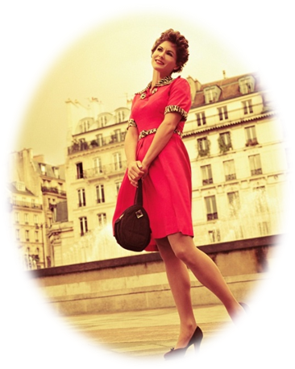
After around five years, Ms. Pulitzer was stressed from her marriage. To help her stop stressing, she started selling fruit from the Pulitzer family’s fruit orchard, and opened a juice stand with a friend who also came from New York. In an interview with People magazine, she said, “I went crazy. People always made decisions for me. The doctor said I should find something to do.” Both women wanted to wear something that would hide juice stains on their clothes. This is why they decided to create colorful patterned dresses. They began selling the dresses at their juice stand for $22 (2000円).

The colorful dress designs became extremely popular. Even Jacqueline Kennedy wore a Pulitzer dress while she was on vacation. The dress design came from colorful kitchen curtain material and had patterns, like tropical and fruit pattern designs.

Lilly’s designs are still sold in many famous department stores, like Bloomingdales, Belk, Lord and Taylor, and Nordstrom.

Adapted from:
Wilson, Eric. “Heiress Who Gave Elite Clothes a Tropical Splash.” The New York Times. 7 April, 2013. http://www.nytimes.com/2013/04/08/fashion/lilly-pulitzer-socialite-turned-designer-dies-at-81.html?pagewanted=all

