Obama is Giving Up 5 Percent of His Pay (Advanced 18)

To show understanding with public workers who are underpaid, Obama is giving up 5 percent - $20,000 – this year. According to CNN, Obama’s $400,000 yearly salary cannot be changed because it is set in law. However starting in April, he will write a check directly to the U.S. treasury (government) every month.
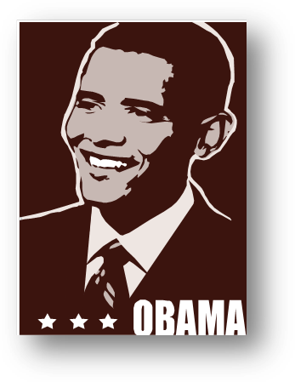

The president wants to share the financial loss that public workers are now experiencing. From March of this year, public workers will have a pay cut. A White house official said, Obama will cut a part of his pay and pay it back to the Treasury.

A day before Obama’s announcement, the new Defense Secretary Chuck Hagel said he was cutting his pay.

Also because of this pay cuts this year, Pentagon workers have to take 14 days of unpaid leave. According to NPR (National Public Radio), “Hagel said he would give up 14 days or $10,750 of his salary.”

The New York Times said, Obama and Hagel’s decision might pressure other public officials to also cut their pay (salary). The White House did not say whether Vice President Joe Biden would cut his pay of $230,700 or not.

On Wednesday afternoon while the president’s decision was announced, Alaska’s Senator Mark Begich also announced that he would freely give a part of his pay back. He also said that his staff members would also give back some of their pay back. The pay cuts this year do not include members of Congress or their assistants.

Adapted From:
Peralta, Eyder. “In Solidarity With Furloughed Workers, Obama Will Give Up 5 Percent Of His Salary.” National Public Radio (NPR). April 3rd, 2013. http://www.npr.org/blogs/thetwo-way/2013/04/03/176182118/in-solidarity-with-furloughed-workers-obama-will-give-up-5-percent-of-his-salary

